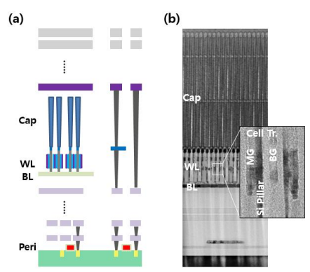
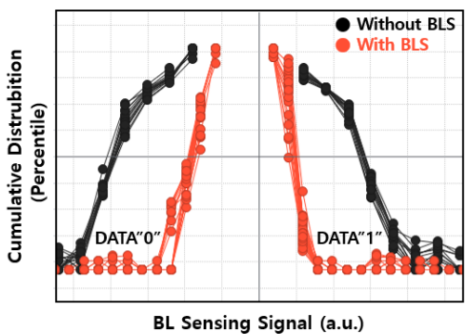
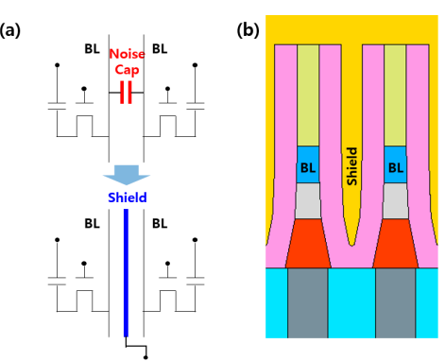
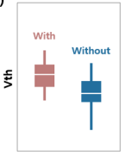
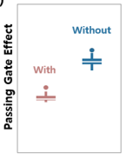
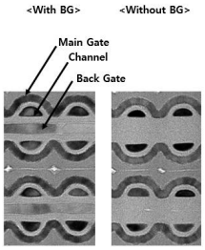

Figures: (Left) (a) Schematic diagram of 4F² VG DRAM cell transistor integrated with peripheral devices through fusion wafer bonding and (b) Cross-sectional TEM image of 4F² VG DRAM (Middle) TEM plane views of VG DRAM array and the effect of Back-gate on the functionality of VG cell transistor. (Right) Conceptual design and schematic diagram of BLS structure - BLS improves significantly the BL sensing failure. (Paper T8.5, “Electrical Characteristics of the 4F2 Vertical Gate (VG) DRAM integrated with BitLine Shielding (BLS) and Back Gate (BG) Transistor,” S. W. Chu et al, SK Hynix)

