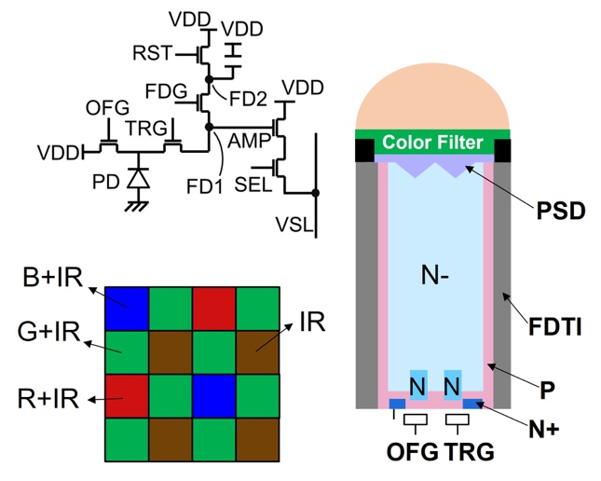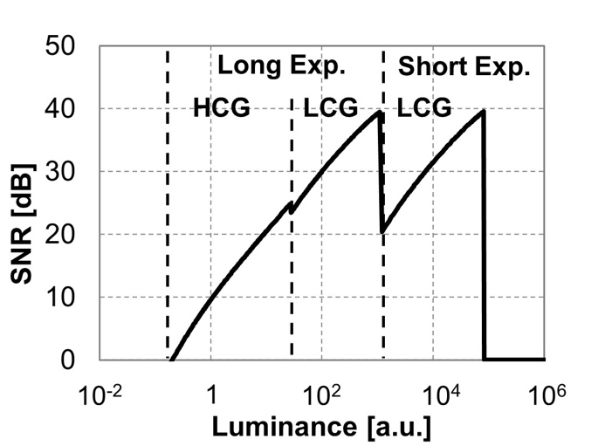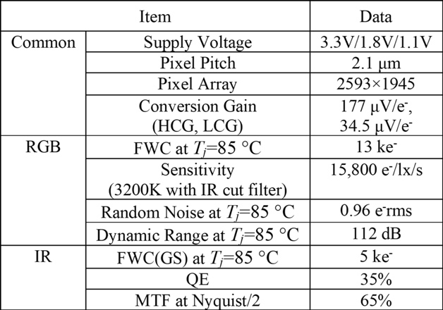
Figures: (Left) The proposed sensor’s pixel schematic and structures. RGB filters also have IR sensitivity. (Middle) The SNR curves of RGB frame at T_{j}=85 °C, achieving a DR of 112dB. (Right) Good pixel performance was achieved in both RGB and IR. (Paper T5.5, “A 2.1-μm Pixel-Pitch CMOS Image Sensor with 65% MTF/35% QE IR Global Shutter and RGB Rolling Shutter Sequential Operation for In-cabin Applications,” M. Hiroki, Sony Semiconductor)

