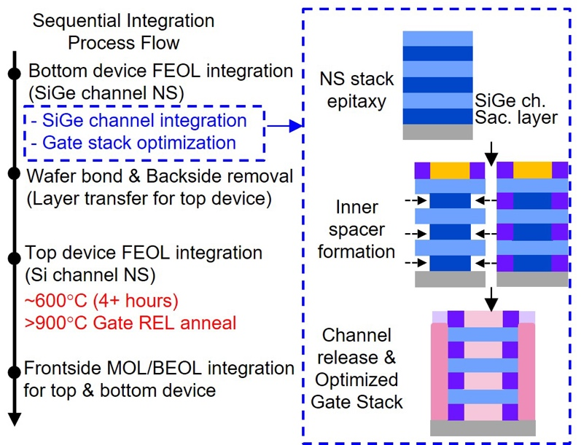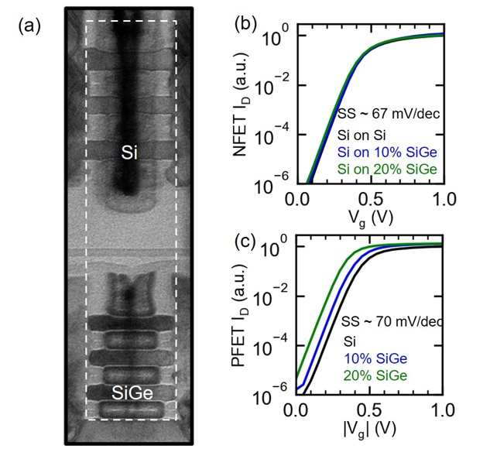
Figures: (Left) High-level integration process flow for stack FET with SiGe GAA NS channel (Bottom) and Si GAA NS channel (Top). (Right) Cross-section TEM of stacked Si NFET on thermally stable SiGe PFET showing excellent overlay. I_{d}-V_{g} curves for Si, 10% SiGe, and 20% SiGe devices after full sequential integration. All PFET devices show subthreshold slopes of ~70 mV/dec, suggesting no additional degradation due to interface traps in the SiGe channel devices. (Paper T5.4, “High-Temperature Resilient SiGe Nanosheet PFET RMG Towards Multi-Tiered Sequential Integration,” N. Shanker et al, IBM Research)

