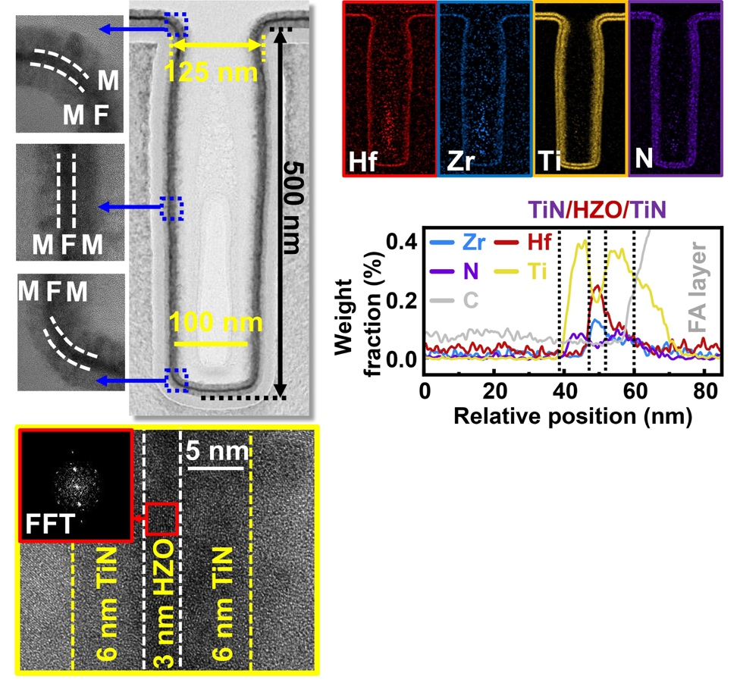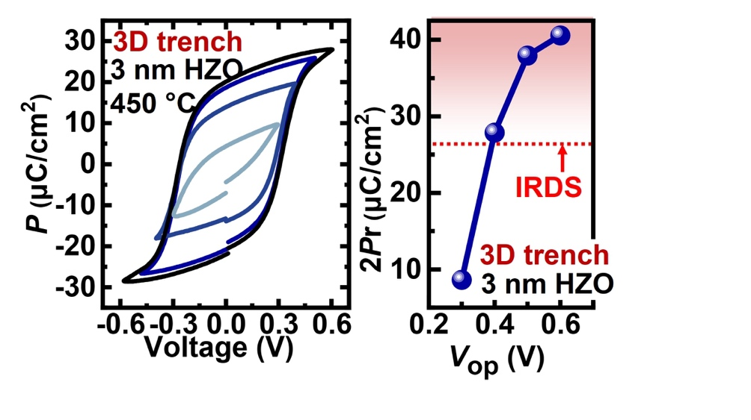
Figures: (Left) TEM images together with FFT and EDX analyses of a fabricated 3D trench MFM capacitor (depth: 500nm; opening diameter: 125nm). (Right) Measured P_{r}-V characteristics loops of a 3nm HZO-based 3D trench FE capacitor annealed at 450℃ with optimized TiN orientation. (Paper T5.3, “Record 2P_{r} (>38μC/cm² at 0.5 V, >28μC/cm² at 0.4V) of 3D MFM Capacitors Enabled by 3nm HZO and ALD-TiN Orientation Engineering, Y. Feng et al, Shandong University”)

