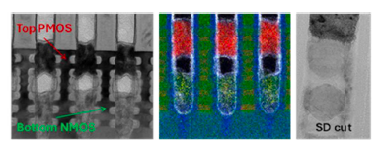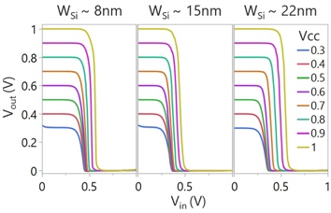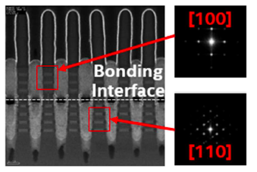
Figures: (Left) TEM micrograph of 2 ribbon CFET device at contacted poly pitch CPP=45nm post vertical dual epi on Si (110) substrate – the first CFET technology with PMOS on top (Middle) Voltage transfer characteristics (VTC) of CFET inverters at CPP=45nm on Si (110) wafers with VCC ranging from 0.3V to 1V, representing the furthest advances in CFET technology to date (Right) EM micrograph of bonded wafers processed using the same monolithic CFET process, showing channel orientation of Si (110) and Si (100). (Paper T5.2, “Demonstration of CFET Inverters on Si (110) with 2X2 RibbonFETs at 45nm Gate Pitch with PowerVia and Direct Backside Contacts,” J. A. Wiedemer et al, Intel Corporation)

