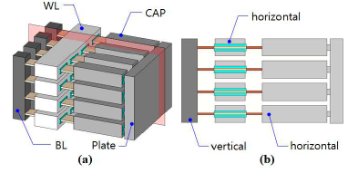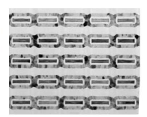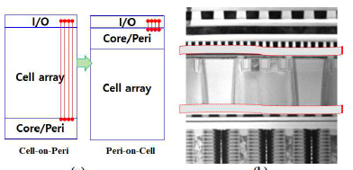
Figures: (Left) (a) Bird eye’s and (b) cross-sectional views of schematic illustration of VS-DRAM with horizontal write line (WL), vertical bit line (BL), and horizontal capacitor. (Right) Cross-sectional TEM image of fabricated gate-all around devices and TEM image of Peri-on-Cell (PoC) emphasizing that the PoC approach is better in terms of I/O efficiency. (Paper T5.1, “Vertically Stacked DRAM Technology for Scaling Evolution,” S.U. Han, Samsung Semiconductor)

