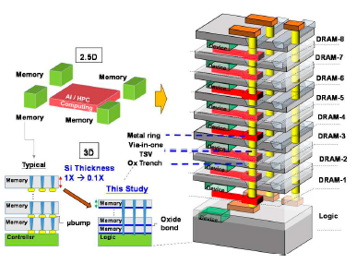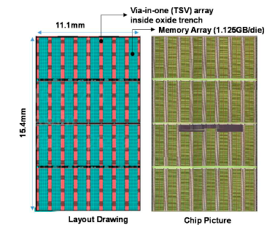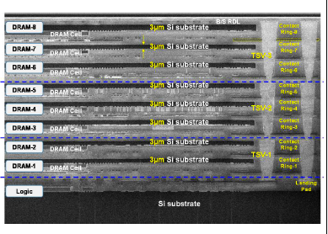
Figures: (Left) Comparison of the typical memory with micro bump in 2.5D packaging vs. fusion-bonded 3D Memory with via-in-one TSV (Middle) Top view of the 3D Memory layout drawing and chip micrograph - the memory array of 1.125GB consists 13.7K via-in-one TSV array per die (Right) Cross-sectional images of the 1+8-stacked Logic/DRAM architecture – extreme thin Si substrate (~3µm) in each DRAM was formed. Via-in-one contacts 2 to 3 metal rings in each set. (Paper T17.5, “Multiple-Wafer (9-layer), Extreme thin (3µm-Si per stack) and Innovative Fusion-bonded Via-in-one Architecture for High Bandwidth 3D Memory,” C.- L. Lu et al, SAIMEMORY Corporation)

