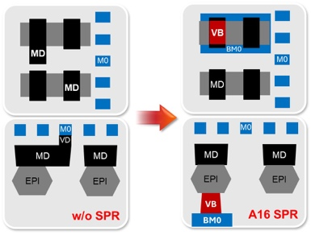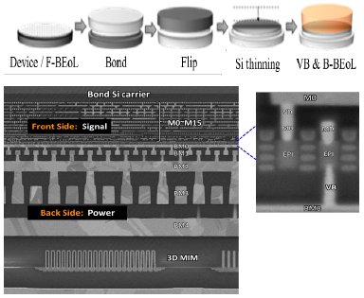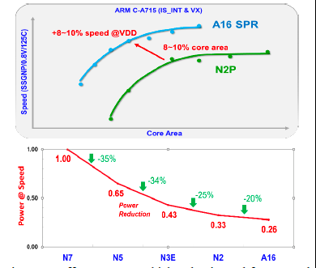
Figures: (Left) Schematic of A16-SPR with backside direct contact (VB) power delivery (Middle) SPR process flow schematics and A16 SPR TEMs showing enhanced nanosheet transistors with backside direct contacts power, front/back-side metals and 3D MiM (Right) A16 offers up to 10% higher density and faster speed than N2P benchmarked on an ARM core. (Paper T1.5, “A16 Angstrom-class CMOS Technology featuring Enhanced Nanosheet Transistors with SuperPower Rail (backside direct contact power delivery) for AI and HPC Applications”, G. Yeap et al, TSMC)

