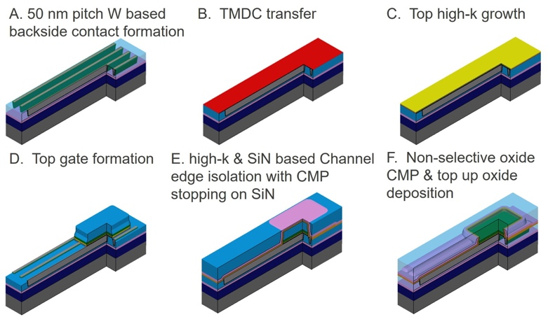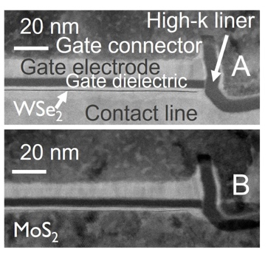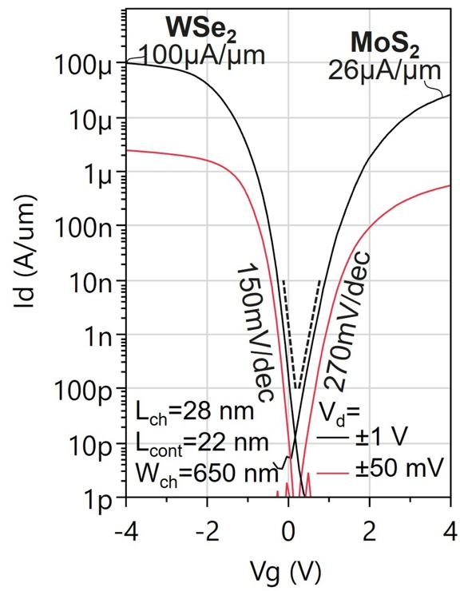
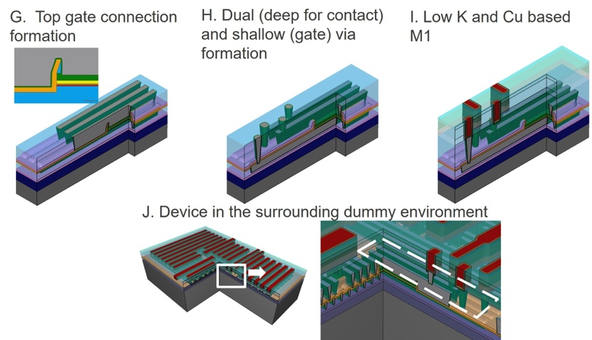
Figures: (Left) Proposed process flow (Middle) Cross-sectional STEM images of fabricated transition metal dichalcogenide (TMD) materials (WSe₂ for NMOS and MoS₂ for PMOS). (Right) I_{d}-V_{g} characteristics of the fabricated NMOS and PMOS devices. (Paper T1.3, “First EUV-enabled Integration Route for 50nm Pitch N and PMOS Transistors with 2D Materials Channel from a 300mm Fab,” T. Schram, imec)

