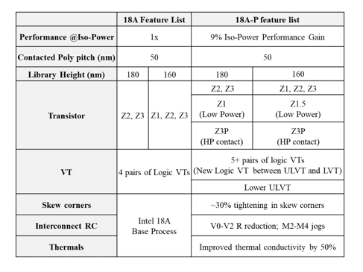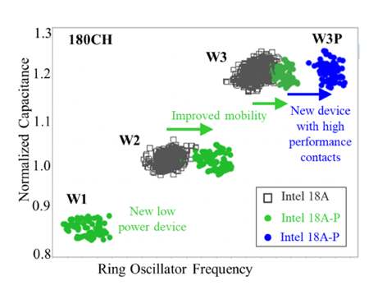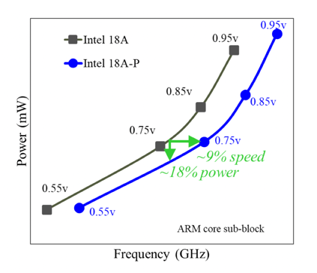

Figures: (Left) Intel 18A-P new technology features compared to Intel 18A (Middle) Performance of new devices (low power and high performance) in 18A-P (Right) Intel 18A-P demonstrates ~9% iso-power performance gain (at 0.75V) over Intel 18A on an industry standard ARM core sub-block. (Paper T1.2, “Intel 18A-P CMOS Technology Enhancement Featuring Advanced RibbonFET (GAA) Transistors and PowerVia for High-Performance Computing,” A. Bowonder, et al, Intel Foundry)

