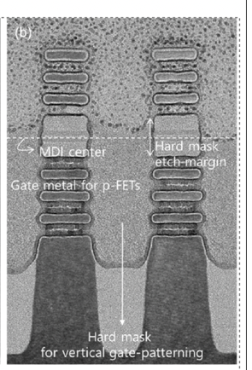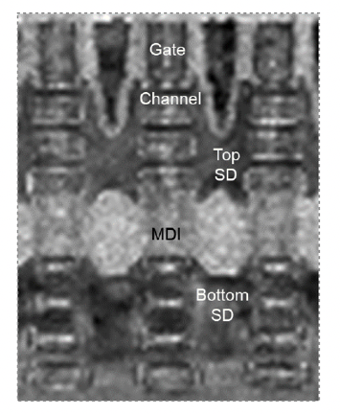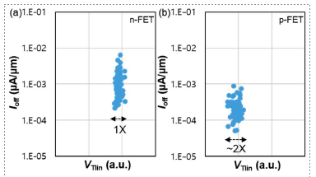

Figures: (Left) TEM image after formation of suitable gate metals for n- and p-FETs. (Middle) TEM image of the final fabricated 3DSFETs at gate pitch of 42nm and triple-stacked nanosheet channels (Right) Electrical characteristics of 3DSFETs with I_{off} vs. I_{Dsat} for n-FETs and p-FETs. (Paper T1.1, “First Demonstration of 3D Stacked FETs at Gate Pitch of 42nm Featuring Triple Stacked Nanosheet Channels for Advanced Logic Applications,” Donghoon Hwang et al, Samsung Electronics)

