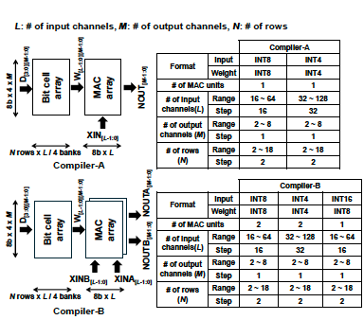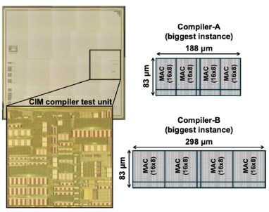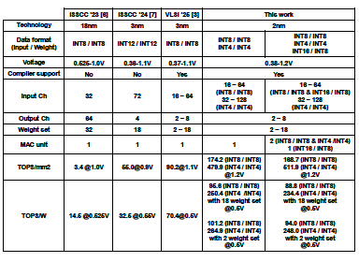
Figures: (Left) Overview of the 2nm CIM compiler supporting multiple data formats and multiple MAC units per weight. (Middle) 2nm test chip including the CIM complier test unit. (Right) Performance comparison demonstrating state-of-the-art energy efficiency and compute density up to 234.4 TOPS/W and 511.9 TOPS/mm². (Paper C8.1, “A 2nm 234.4TOPS/W and 511.9TOPS/mm² Digital Computing-in-Memory Compiler with Multiple MAC Units per Weight and Multiple Data Format Support,” Hidehiro Fujiwara et al, TSMC)

