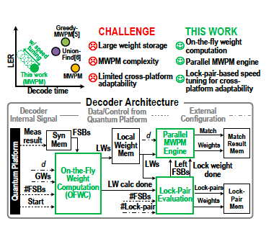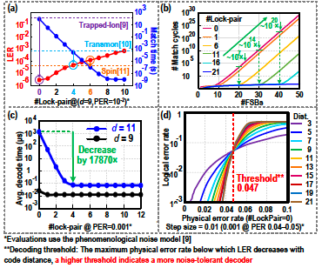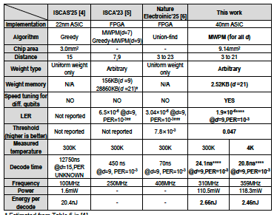
Figures: (Left) Key advantages and overall architecture of the proposed decoder. (Middle) Measured lock-pair-based speed tuning (a); match cycles versus number of FSBs (b); decoding time (c); decoding threshold (d). (Right) Performance summary and comparison with state-of-the-arts. (Paper C7.3, “A Full-MWPM Surface Code Decoder with On-the-Fly Weight Computation and Cross-Platform Adaptability Achieving 1.9×10⁻⁶ LER and 20.8-ns Decode Time at 4K,” H. Lyu and Y. Chen et al, Southern University of Science and Technology)

