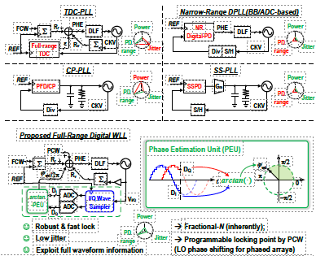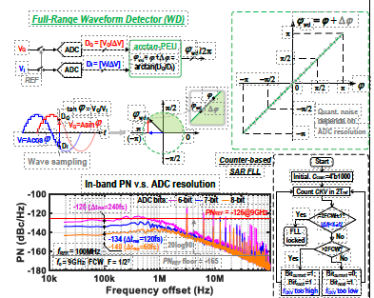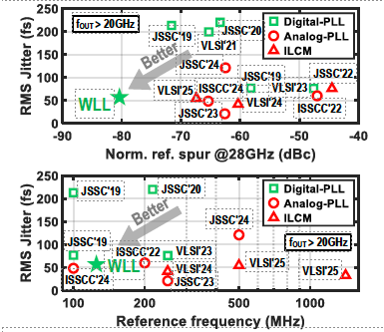
Figures: (Left) Conceptual comparison of conventional PLL architectures and the proposed waveform-based digital WLL. (Middle) Arctangent-based waveform detector enabling full-2π phase detection with high resolution. (Right) Comparison of jitter performance vs normalized ref. spur at 28GHz, and vs. ref. frequency for SoTA PLLs. (Paper C4.4, “A 28-GHz Quadrature LO-Phase-Shifting Digital Wave-Locked Loop (WLL) Achieving 57.2-fs_{rms} Jitter, −80.6-dBc Spur_{ref}, and 0.59µs Near-Integer Lock Time,” Feifan Hong et al, University College Dublin)

