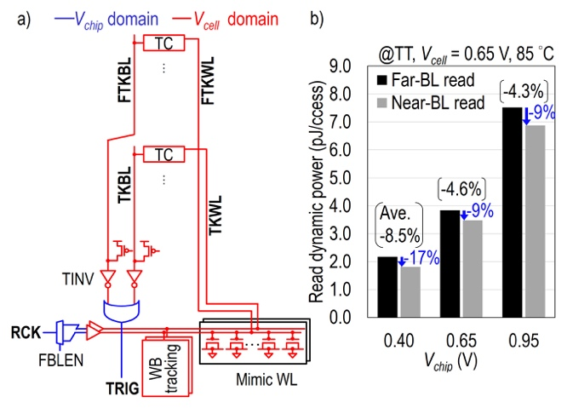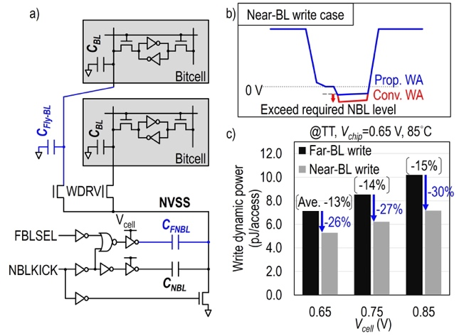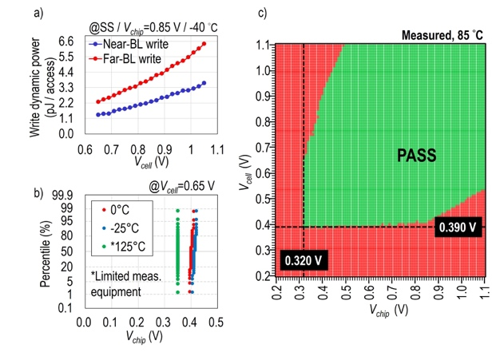
Figures: (Left) Proposed row-access aware read tracking, a) schematic, b) read dynamic power comparison between near- and far-BL read. (Middle) Proposed row-access aware WA circuit and its impact on write dynamic power, a) schematic, b) NBL waveforms, c) write power comparison for near- and far-BL. (Right) Measured silicon data, a) measured write dynamic power, b) V_{min} distribution, c) V_{chip} vs. V_{cell} shmoo plot. (Paper C29.1, “A 2nm 37.4 Mbit/mm² Dual-Rail SRAM with Row-Access Aware Read Tracking and Write Assist Circuits Enabling 2.28pJ/Access Energy Efficient Operation,” R. Takamatsu et al, TSMC)

