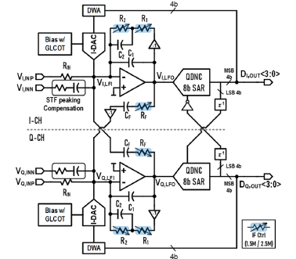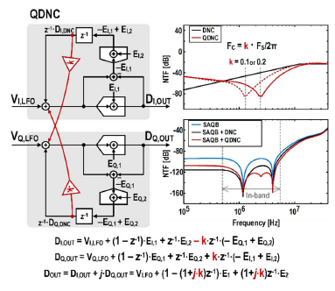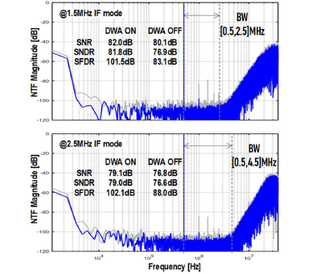
Figures: (Left) Proposed quadrature CT ΔΣ modulator architecture using SAQB and digital noise coupling. (Middle) Quadrature digital noise coupling (QDNC) mechanism enabling flexible IF operation and robust high-order noise shaping. (Right) Measured output spectra showing high SNDR and effective in-band noise suppression for both IF modes. (Paper C28.5, “Robust Configurable 1.5MHz / 2.5MHz IF Quadrature CT ΔΣ Modulator Using SAQB and QDNC for 175.4dB FoMs in 14nm FinFET,” Seong-Eun Cho et al, Samsung Electronics)

