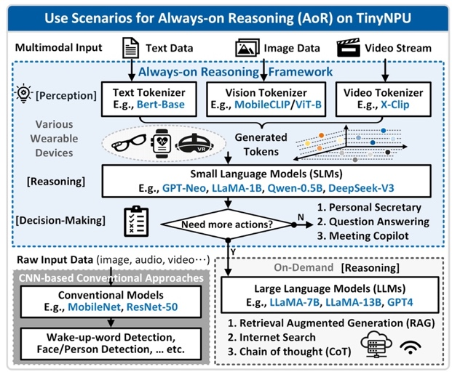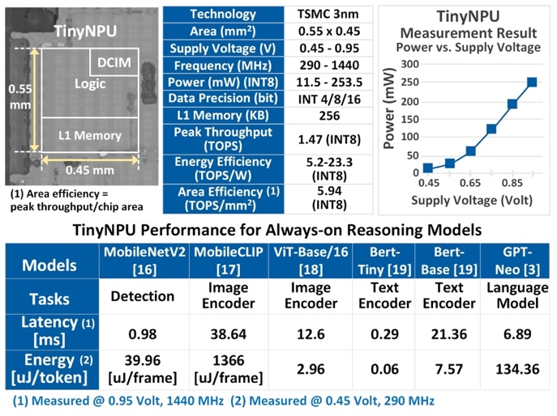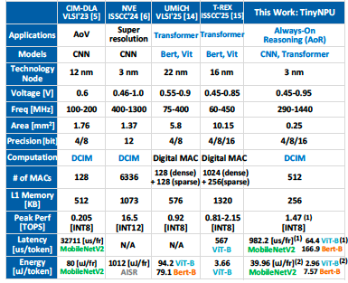
Figures: (Left) TinyNPU use scenarios. (Middle) Chip micrograph and measured TinyNPU performance. (Right) Performance summary and comparison with state-of-the-arts. (Paper C21.1, “TinyNPU: A 3nm 0.06-134.36 μJ/token DCIM-Based Ultra Low Power NPU for Always-On Reasoning on Wearables,” Y. Hsieh, E. Chang, C. Teng et al, MediaTek)

