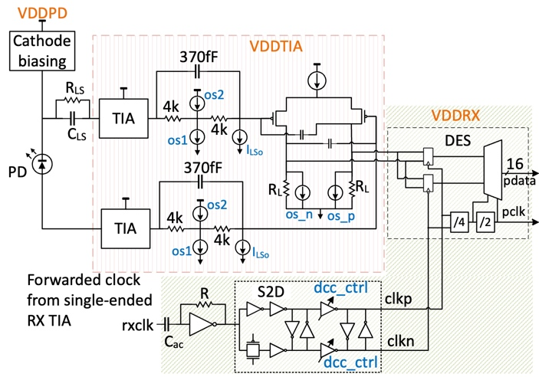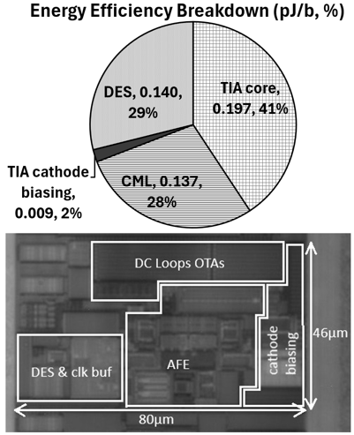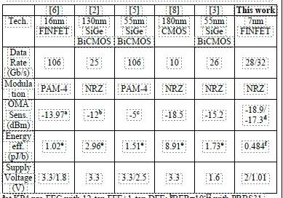
Figures: (Left) Proposed receiver circuit diagram with the differential TIA. (Middle) Chip micrograph and energy efficiency breakdown. (Right) Performance summary and comparison with state-of-the-arts. (Paper C20.2, “A 32Gb/s Optical Receiver utilizing a Differential TIA with -17.3dBm Sensitivity in a3D-stacked Silicon Photonics Platform,” G. Kalogerakis et al, NVIDIA)

