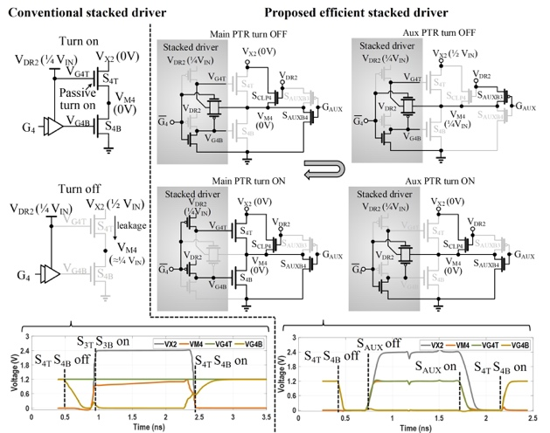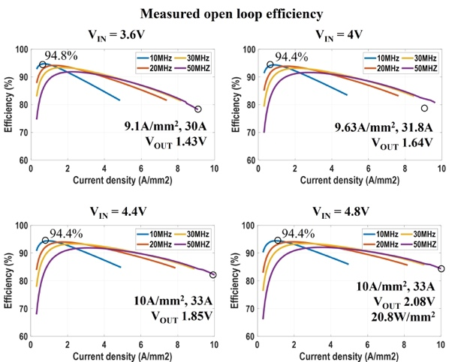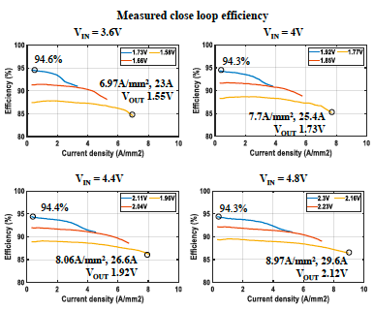
Figures: (Left) Comparison between conventional and proposed stacked-devices gate driving scheme. (Middle) Measured open-loop efficiency. (Right) Measured closed-loop efficiency. (Paper C2.1, “A Monolithic 20W/mm² 4.8V Input 94.8% Peak Efficiency 2-1 Switched Capacitor Voltage Regulator as First-Stage Current Multiplier for Vertical Power Delivery,” M. Gong et al, Intel)

