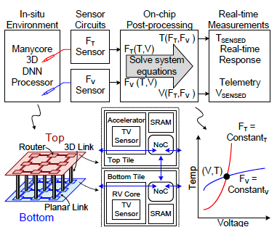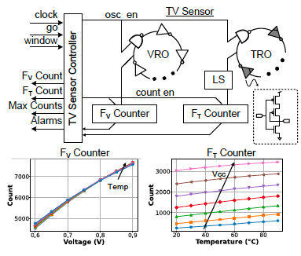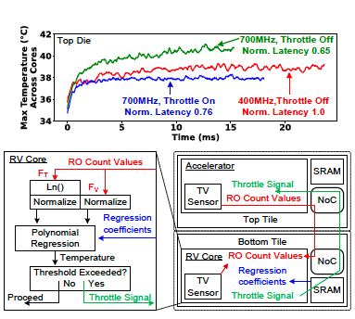
Figures: (Left) Placement of distributed thermal-voltage sensors in a hybrid-bonded 3DIC DNN processor. (Middle) Unified digital TV sensor architecture based on dual ring oscillators and on-chip processing. (Right) Measured system-level impact showing real-time thermal monitoring and dynamic throttling for improved performance and thermal control. (Paper C10.5, “Unified Digital Thermal-Voltage Sensor for Thermal Management in Intel 18A/Intel 3,” Shanshan Xie et al, Intel Corporation)

