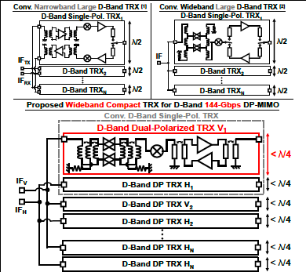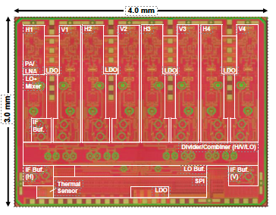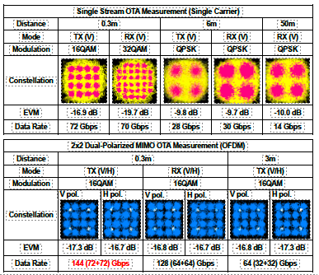
Figures: (Left) Proposed D-band DP-MIMO phased-array architecture highlighting compact λ/4 TRX integration for vertical and horizontal polarizations. (Middle) Die micrograph of the 65nm CMOS transceiver integrating 4V+4H TRX elements in a 3mm × 4mm chip. (Right) Measured OTA performance demonstrating up to 144Gbps DP-MIMO data rate and long-range communication capability. (Paper C1.5, “A 144Gbps D-Band Dual-Polarized MIMO High-Density Phased-Array Transceiver in 65nm CMOS for 6G UE,” 22Yudai Yamazaki et al, Institute of Science Tokyo)

