Regular Paper Format for Symposium on VLSI Technology and Circuits in Two-Column Format
Yellow markers indicate important information and requirements which must be followed.
Center the Authors Names Here
Center the Affiliations, City, States and Country

Abstract
The abstract is a concise (60 to 150 words) summary of your 3-page paper, providing an overview of the research. This is an important aspect of your paper, as it is this description that may attract the reader. Key performance and figures of merit are often mentioned in the abstract.
Keywords (optional): Each keyword, except proper nouns and acronyms, should be typed in lower-case letters and followed by a comma, except for the last one.
Introduction
These guidelines help prepare camera-ready papers for the VLSI Symposium. Note that papers that do not follow the guideline will be rejected. The aim is to closely simulate the appearance of published papers in the VLSI Symposium Digests. Your manuscript should be IEEE Xplore®-compatible through PDF eXpress during submission.
Space is a precious resource in VLSI Symposium papers. Typically, there are no empty lines between section titles and text. If the text starts on the same line as the Section title, emphasize the title in bold or italic. Subsections are rarely used but can be highlighted with italicized fonts and continued on the same line.
Several past VLSI papers had issues with text in the figures too small to read when printed on paper. To address this, the paper length has been increased from 2 to 3 pages since VLSI 2025, doubling the area available for figures so that larger font sizes can be used. The amount of information should not exceed past VLSI papers. For instance, doubling the number of figures with the same font size as in past VLSI papers is prohibited. The font size of the text in the figures must be at least 8 points. Papers that violate the font size rule will be rated unfavorably or rejected.
The second and third pages are divided into a 2 x 3 grid, creating six panes which are primarily for figures, but can also be used for references if needed. These panes are fixed, and must not be changed. These grid lines must not be removed either. The main text, acknowledgments, and references should be on page 1, with the figures on the subsequent pages. If space on page 1 is insufficient, one of the six panes in page 3 can be used for references.
(1) Paper size: Prepare camera - ready paper in full size format, on A4 size or 8 1/2” x 11” (215.9 mm x 279.4 mm) paper.
(2) Fonts: The best results are obtained by careful and effective use of several font sizes. Do not use fonts smaller than the fonts specified in Table I. As an aid to gauging font size, 1 point is about 0.35 mm. Use a proportional, serif font such as Times or Dutch Roman. Arial and Calibri fonts are often used for figure captions and labels.
(3)Formats: In formatting your A4-size paper, set top margin to 20 mm (0.79 inches), bottom margin to 25 mm (0.98 inches), left margin to 14 mm (0.55 inches) and right margin to 15 mm (0.59 inches). If you are using paper 8 1/2” x 11”, set the top margin to 10 mm (0.39 inches), bottom margin to 17.4 mm (0.69 inches), left margin to 17 mm (0.67 inches), and right margin to 17.9 mm (0.70 inches). The column width is 88 mm (3.46 inches) with 5 mm (0.20 inches) space between the two columns.
You should left- and right-justify your columns. On the last page of your paper, try to adjust the lengths of the two columns so that they are the same. Use automatic hyphenation, if you have it. Don't forget to check spelling.
Illustrations
The font size of the text in the figures must be at least 8 points. Papers that violate the font size rule will be rated unfavorably or rejected. Figure captions should be below the figures; table captions should be above the tables. Use the abbreviation (e.g., “Fig.1”) for immediate identification even at the beginning of a sentence. Curves in the graphs should be colored with high contrast (e.g. avoid yellow on light background). To this end, use appropriate symbols and line styles (solid, dashed, etc.). Make sure all figures captions, legends, tick and axis labels are easily readable. Plotted figures and tables must be mentioned in the text.
Helpful Hints
A. References: Place a list of numbered references at the end of the paper. When references are made in the main text, the corresponding reference number should be included in square brackets [1]. The sentence punctuation follows the brackets. Cited references should unambiguously identify the source. Use complete citations if space allows, i.e., state the paper title and the names of all authors. Unpublished papers should be cited as “unpublished” [4], and accepted papers as “in press” [5]. DOI is required for each and every reference in VLSI papers (see details in References section how to add DOI). Capitalize only the first word in the paper title, except for proper nouns and element symbols. For papers in translated journals, give the English citation first, followed by the original foreign-language citations [6].
B. Abbreviations and Acronyms: Define abbreviations and acronyms the first time they are used. Acronyms such as MOSFET, ac and dc etc. do not have to be defined. Redefine acronyms when first used in the text, even if they have been defined in the abstract.
C. Equations: Number equations consecutively with equation numbers in parentheses flush with the right margin, as in (1). To make your equations more compact, you may use the solidus (/), the exp function, or appropriate exponents. Italicize Roman symbols for quantities and variables, but not Greek symbols. Use a long dash rather than a hyphen for a minus sign. Use parentheses to avoid ambiguities in denominators. Punctuate equations with commas or periods when they are part of a sentence, like this,
$f\left(x\right)=a_{0}+\sum_{n=1}^{∞}{\left(a_{n}\cos{\frac{nπx}{L}}+b_{n}\sin{\frac{nπx}{L}}\right).}$ (1)
Be sure that all the symbols in your equation have been defined before the equation appears or immediately afterwards. When you refer to equations in the text, refer to (1). Do not use “Eq. (1)” or “Equation (1)” except at the beginning of a sentence: “Equation (1) is used....”
Acknowledgements to people, funding agencies, projects have to be on page 1, right after the main text and before the references.
References
[1] Z. Zhou et al., IEEE TED, vol. 71, no. 8, pp. 4445–4452, 2024, doi: 10.1109/TED.2024.3403084.
[2] P. Jiang et al., IEDM, 2023, pp. 1–4, doi: 10.1109/LED.2024.352425.
[3] Q. Xie et al., Symp. on VLSI, 2023, pp. 1–2, doi: 10.1109/LED.2024.3368522.
[4] A. Einstein, Ph. D. dissertation, XYZ-Univ., Unpublished.
[5] T.A. Edison, in press, ABC_Journal.
[6] T. Kodera, JSAP Rev. 2024 240101 / Oubutsu 2023 p713-722, doi: https://doi.org/10.11470/jsaprev.240101.
[7] G. Park et al., ISSCC, 2024, pp. 374–376, doi: 10.1109/ISSCC49657.2024.10454487.
[8] N. Zeng et al., Symp. on VLSI, 2023, pp. 1–2, doi: 10.1109/ESSDERC59256.2023.10268548.
DOI is required for each and every reference (except unpublished references). The hyperlink to DOI must be removed, as above examples, to comply with PDF eXpress.

references unpublished)..

TABLE I. Font sizes for camera-ready papers | 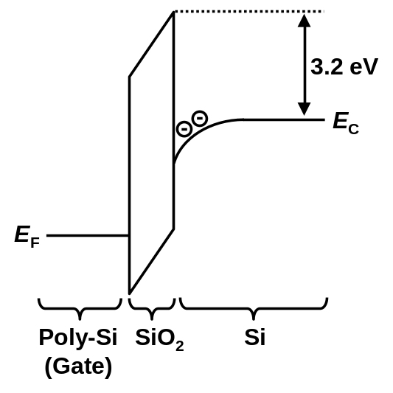  Fig. 1. Write the figure caption here. The font size of the text in the figures must be at least 8 points. Papers that violate the font size rule will be rated unfavorably or rejected.
  Font Size | Bold | Italic | Text
  10 |  |  | Main text, authors’ affiliations
  10 | Yes |  | Headings, i.e. Abstract
  12 |  |  | Authors’ names
  14 | Yes |  | Paper title
  10 |  | Yes | Sub-headings, i.e., Fonts
  9 |  |  | References, table, table names, table captions, figure captions
  8 |  |  | Footnotes, sub- and superscripts
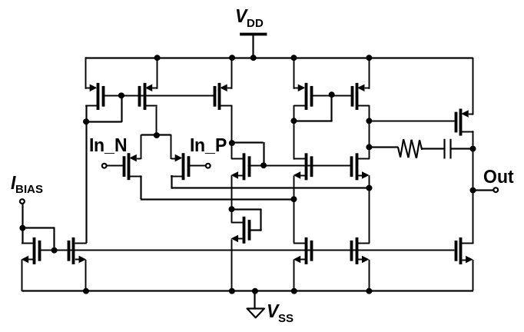  Fig. 2. Write the figure caption here. The font size of the text in the figures must be at least 8 points. Papers that violate the font size rule will be rated unfavorably or rejected. | 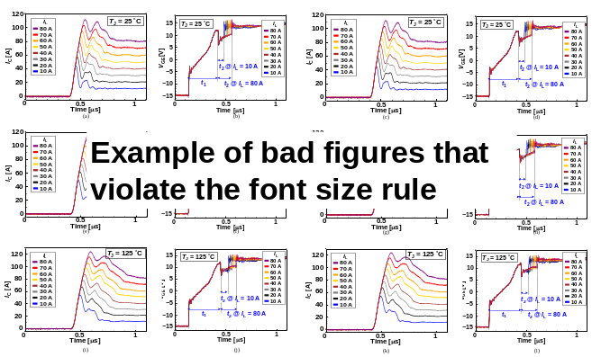  Fig. 3. (Bad example – must be avoided) Do not squeeze many sub-figures into one pane which violates the font size and makes it unreadable.
Fig. 4. (Good example) More than one figure could be placed in one pane as long as the font size of the text in the figures must be at least 8 points. | Fig. 5. Write the figure caption here. The font size of the text in the figures must be at least 8 points. Papers that violate the font size rule will be rated unfavorably or rejected.
Fig. 6. Write the figure caption here. The font size of the text in the figures must be at least 8 points. Papers that violate the font size rule will be rated unfavorably or rejected. | Fig. 7. Write the figure caption here. The fFig. 7. Write the figure caption here. The font size of the text in the figures must be at least 8 points. High contrast colors for different curves are required.
Fig. 8. Write the figure caption here. The font size of the text in the figures must be at least 8 points. Papers that violate the font size rule will be rated unfavorably or rejected. | Fig. 9. Write the figure caption here. The font size of the text in the figures must be at least 8 points. Papers that violate the font size rule will be rated unfavorably or rejected.
TABLE II. Comparison with state-of-the-art AAAA circuits. The font size of the text in the table must be at least 8 points. | References  [1] Z. Zhou et al., IEEE TED, vol. 71, no. 8, pp. 4445–4452, 2024, doi: 10.1109/TED.2024.3403084.  [2] P. Jiang et al., IEDM, 2023, pp. 1–4, doi: 10.1109/LED.2024.352425.  [3] Q. Xie et al., Symp. on VLSI, 2023, pp. 1–2, doi: 10.1109/LED.2024.3368522.  [4] A. Einstein, Ph. D. dissertation, XYZ-Univ., Unpublished.  [5] T.A. Edison, in press, ABC_Journal.  [6] T. Kodera, JSAP Rev. 2024 240101 / Oubutsu 2023 p713-722, doi: https://doi.org/10.11470/jsaprev.240101.  [7] G. Park et al., ISSCC, 2024, pp. 374–376, doi: 10.1109/ISSCC49657.2024.10454487.  [8] N. Zeng et al., Symp. on VLSI, 2023, pp. 1–2, doi: 10.1109/ESSDERC59256.2023.10268548.  In case there is not enough space in the first page, one pane of page-3 can be used for references. DOI is required for each and every reference (except unpublished references). The hyperlink to DOI must be removed, as above examples, to comply with PDF eXpress.
   | CICC'20  [1] | JSSC'23  [3] | VLSI'23  [4] | This work
  Target power  device | IGBT | SiC  MOSFET | Si  MOSFET | IGBT
  Feedback control  target | V_{GE}  waveform | Timing of state change | Timing of state change | Timing of state change
  Real-time control | Yes | Yes | No | Yes
  Levels of parameter |  | 2 | 2 | 6 bit
  IC Process
  Board / IC | PCB | PCB | IC | IC
  Target power  device | IGBT | SiC  MOSFET | Si MOSFET | IGBT

